**Incredible images from volcano erupting in Chile**

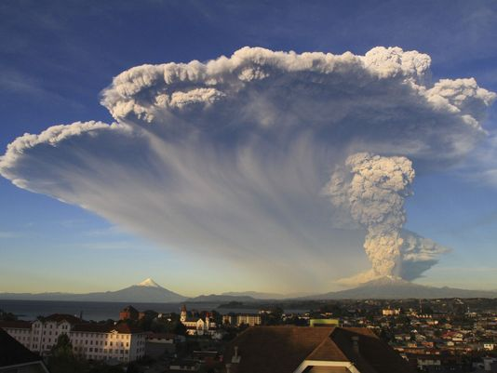Luis Andres Henao, USA TODAY, Associated Press 3:28 p.m. EDT April 23, 2015

SANTIAGO, Chile (AP) — Twin blasts from the Calbuco volcano in southern Chile have sent vast clouds of ash into the sky, increasing concerns that it could contaminate water, cause respiratory illnesses and ground more flights.

The volcano erupted Wednesday afternoon for the first time in more than four decades, sending a towering plume of ash more than 6 miles (10 kilometers) into the air. Emergency officials were taken by surprise and had only a few minutes to issue an alert.

The Calbuco volcano erupted Wednesday for the first time in more than 42 years, billowing a huge ash cloud over a sparsely populated, mountainous area in southern Chile. (April 22) AP

Calbuco had another spectacular outburst early Thursday lightning crackling through a dark sky lit orangish red by the explosion.

As the ash cloud spread, "people went into a state of panic," said Miguel Silva Diaz, 28, an engineer who lives in Puerto Montt, a city about 14 miles from the volcano.

"Then, at around 1 a.m., I heard a loud noise, as if somebody had detonated an atomic bomb."

No injuries were reported and the only missing person since the eruption was found on Thursday. Authorities evacuated 4,000 people as gas and ash continued to spew, and they closed access to the area around the volcano, which lies near the cities of Puerto Varas and Puerto Montt, some 620 miles south of Santiago.

"I was shocked. I had just arrived home when I looked through the window and saw the column of smoke rising up. We called our families, posted photos," said Daniel Palma, 30, a psychologist who lives in Puerto Varas.

"We woke up today with a blanket of fog and it hasn't cleared. We have a layer of smoke above us," Palma said, adding that many are concerned about the possible effects of the ash on their health.

President Michelle Bachelet declared a state of emergency, saying the eruption of Calbuco is "more serious and unpredictable" than the one last month at the Villarica volcano, which also forced the evacuation of thousands.

Ash continued to fall Thursday in Puerto Montt and other nearby cities, said 30-year-old Patricio Vera, the director of a local radio station. Varas said that after the eruption, hundreds of people rushed to get gas, forcing stations to ration sales, while supermarkets closed early to avoid the risk of looting.

The 6,500 foot Calbuco last erupted in 1972 and is considered one of the top three most potentially dangerous among Chile's 90 active volcanos.

LATAM airlines cancelled flights to and from Puerto Montt because airborne ash can severely damage jet engines.

In 2011, a volcano in the Caulle Cordon of southern Chile erupted violently, forcing the cancellation of hundreds of flights and the evacuation of more than 3,500 people. Stiff winds blew ash, and the thick abrasive soot coated slopes in the sky resort city of San Carlos de Bariloche, over the border in Argentina.

By Thursday afternoon, much ash had made its way to Villa La Angostura, Argentina, a small town about 56 miles (90 kilometers) northeast of the volcano. Cars and streets were coated with a thin layer of ash, but people were otherwise going about their business.

"We are praying that the volcanic activity will be as short as possible," said mayor Roberto Cacault.